**Lab2 my work & Screenshots:**

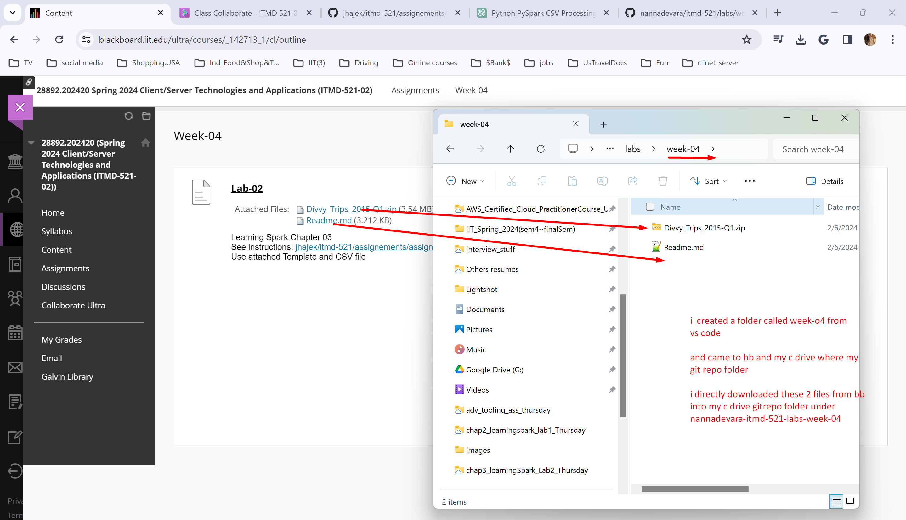

And then came to vs code…my gitrepo…the files appeared here…I did commit…push..refreshed my github and then did git pull in vagrant box to pull these into my vagrant box repo also

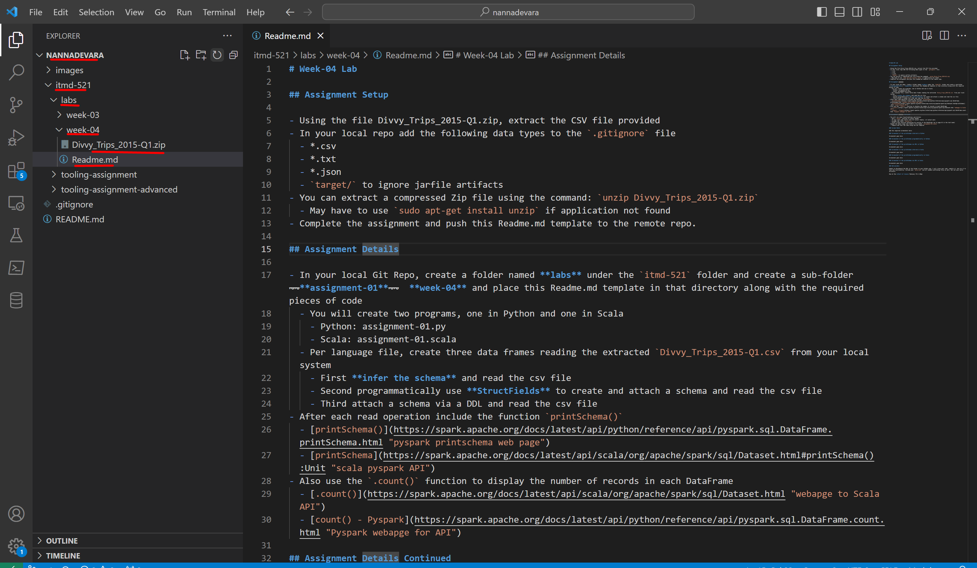

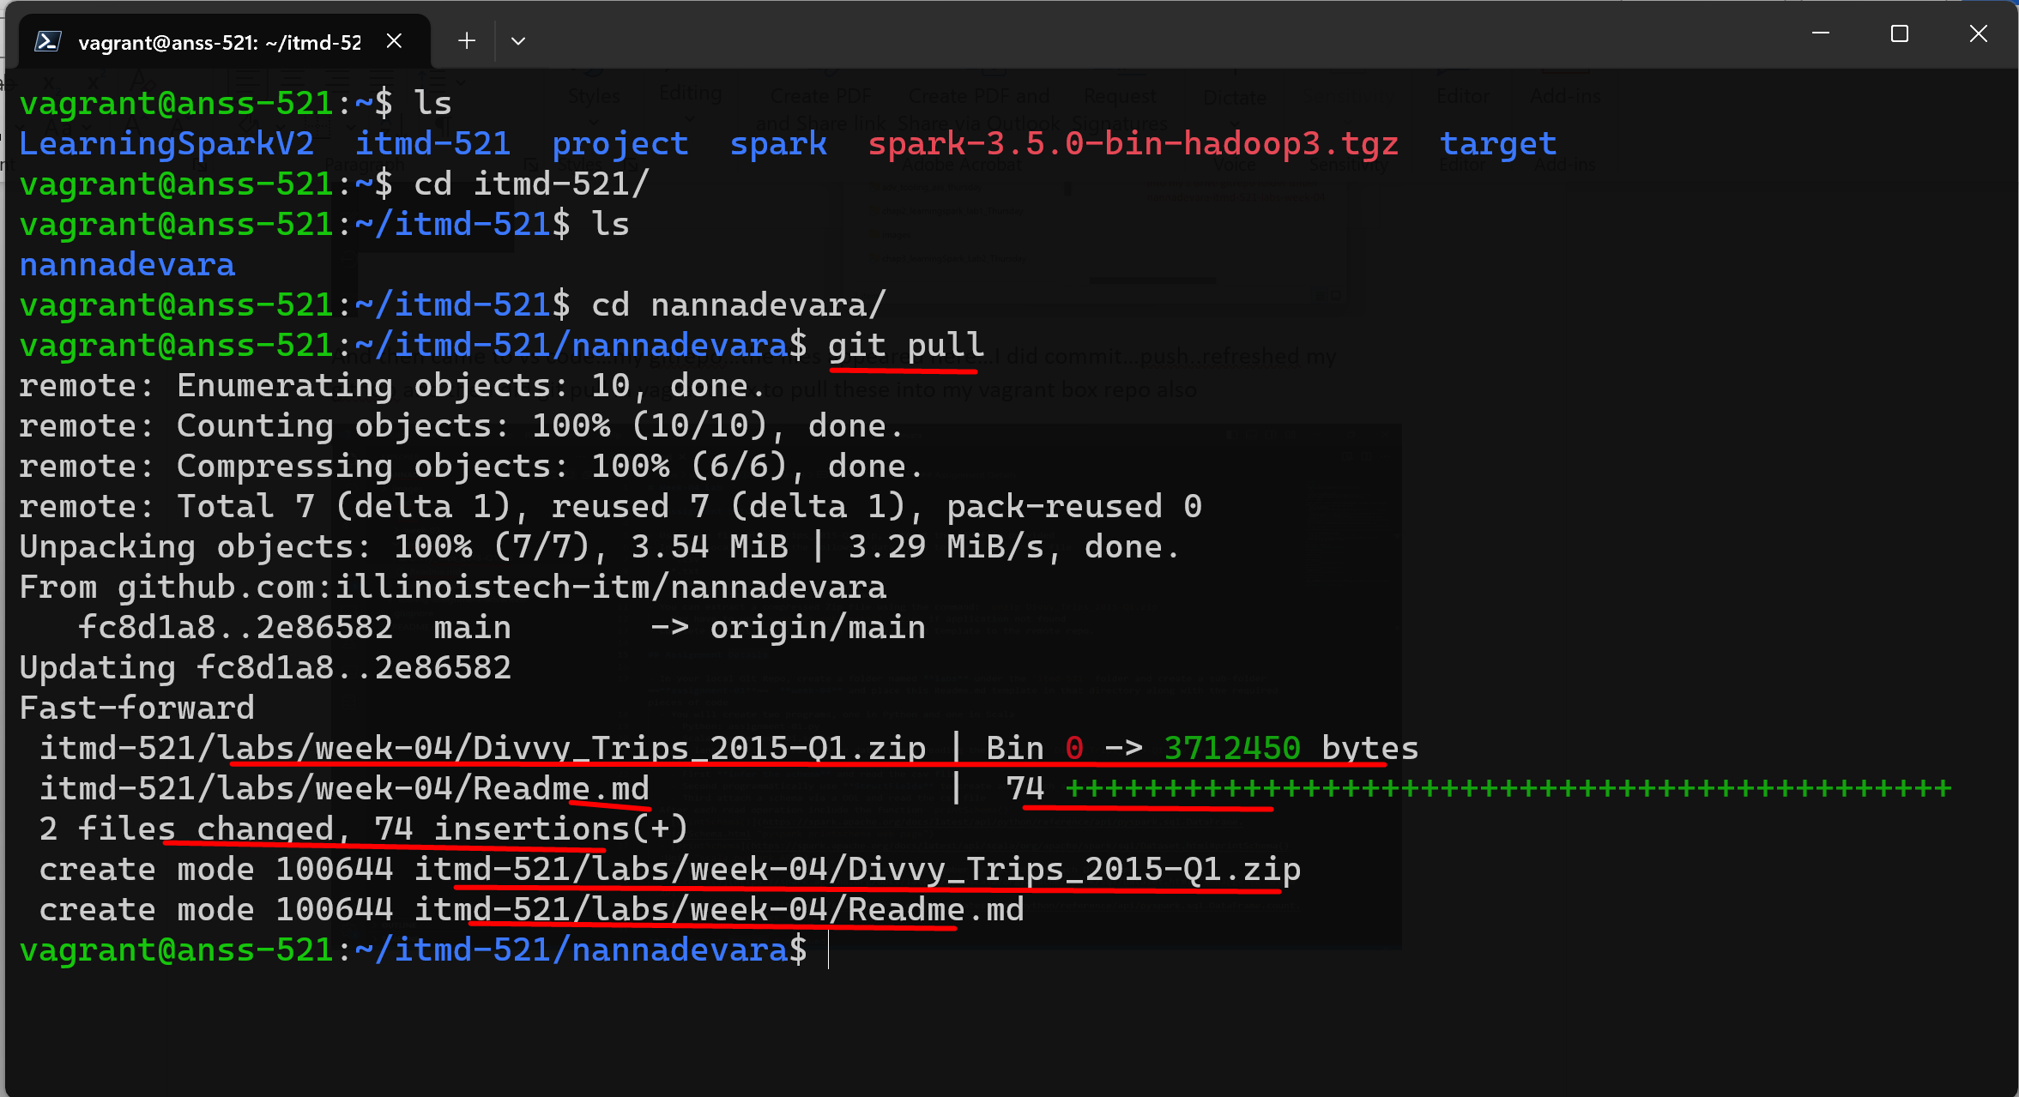

We have the zip file and readme in our vagrant box git repo folder too

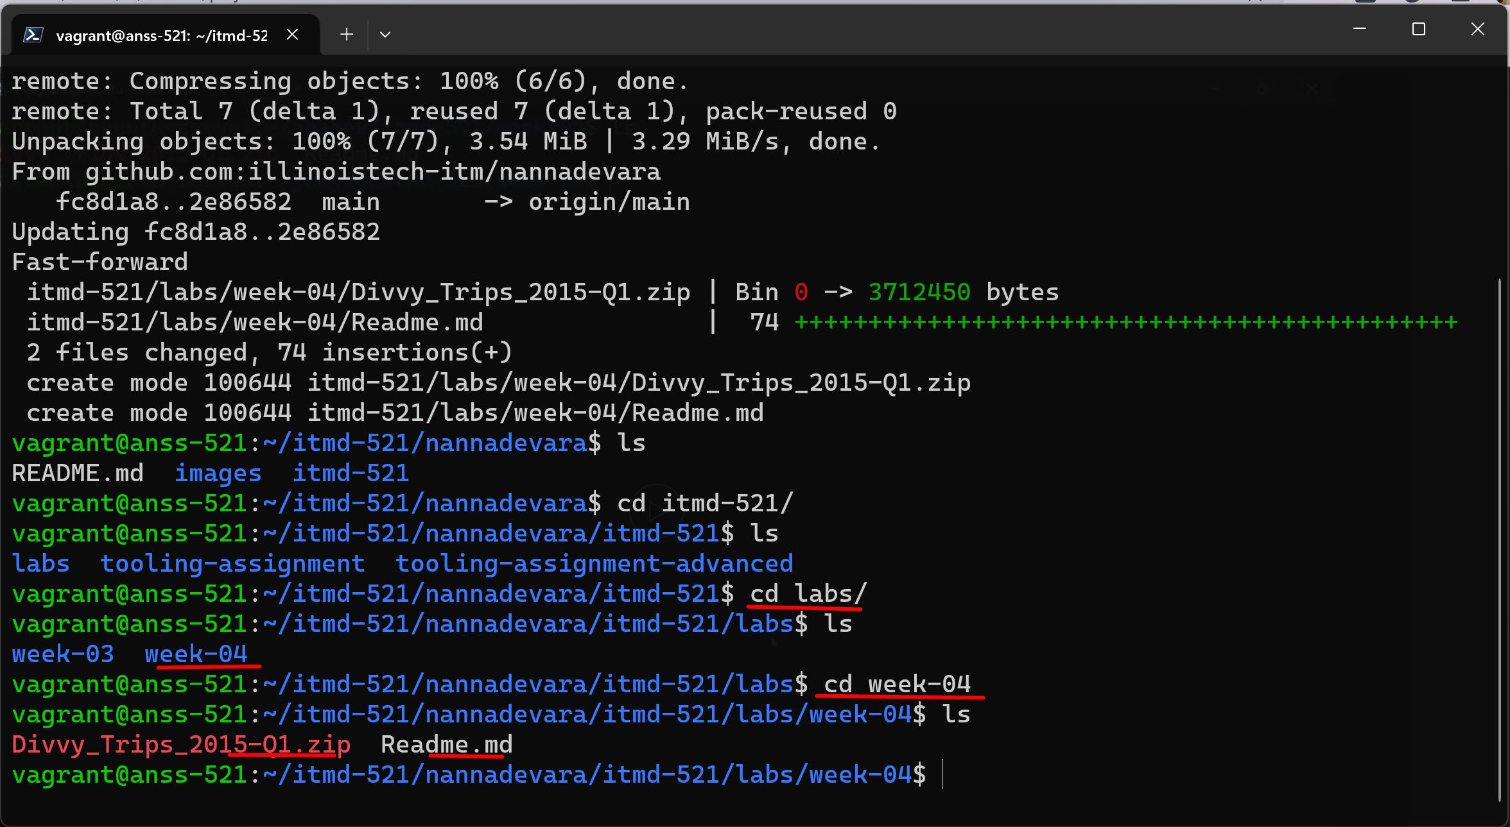

Now we need to unzip it

How do we do that? We need to install one more package called unzip

But before that we need to do sudo apt update just to check if there are any updates

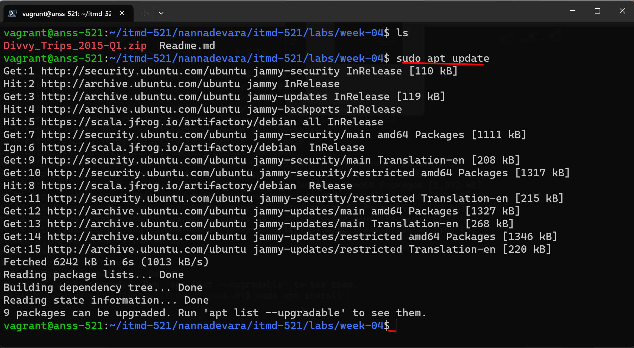

Now lets install unzip package

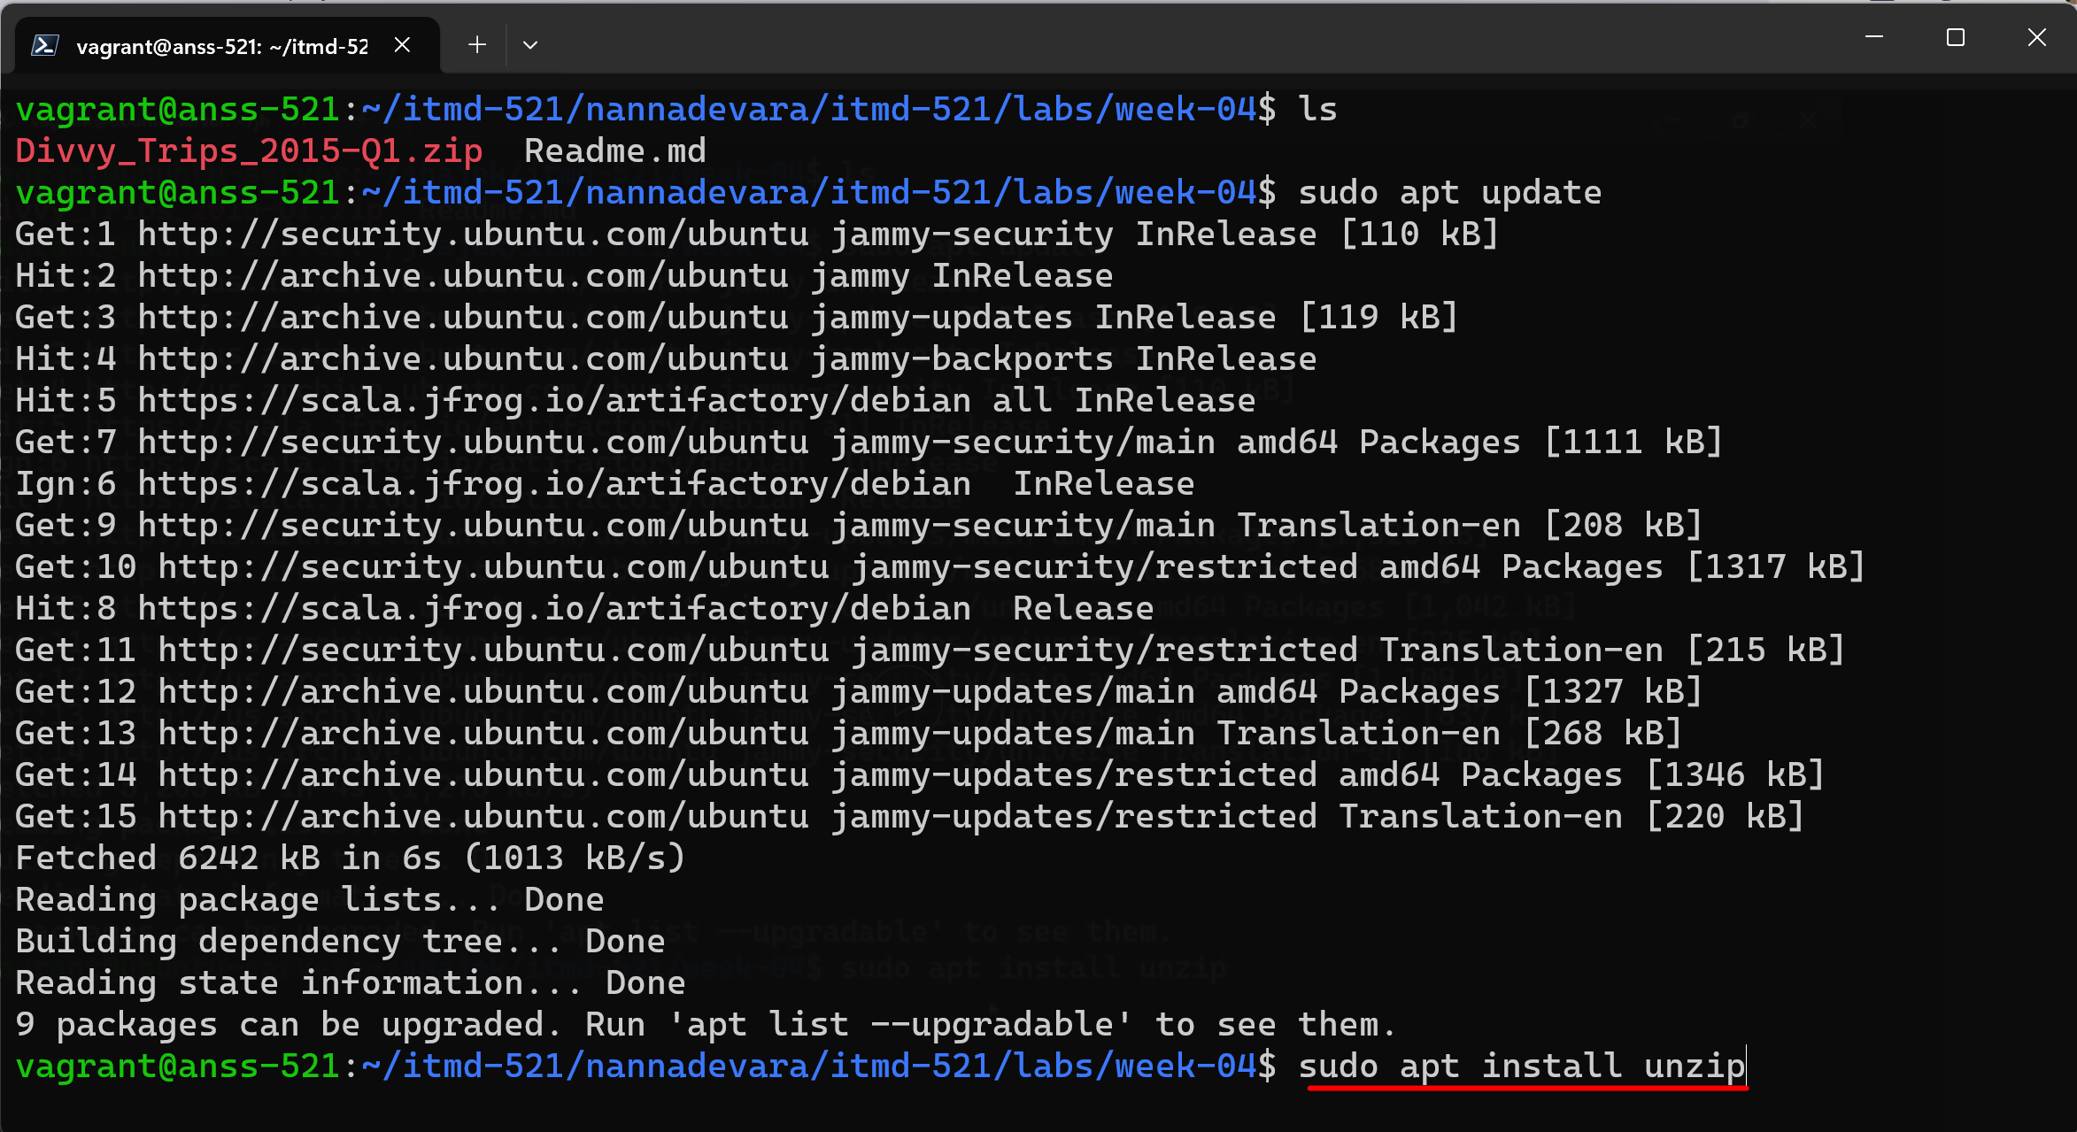

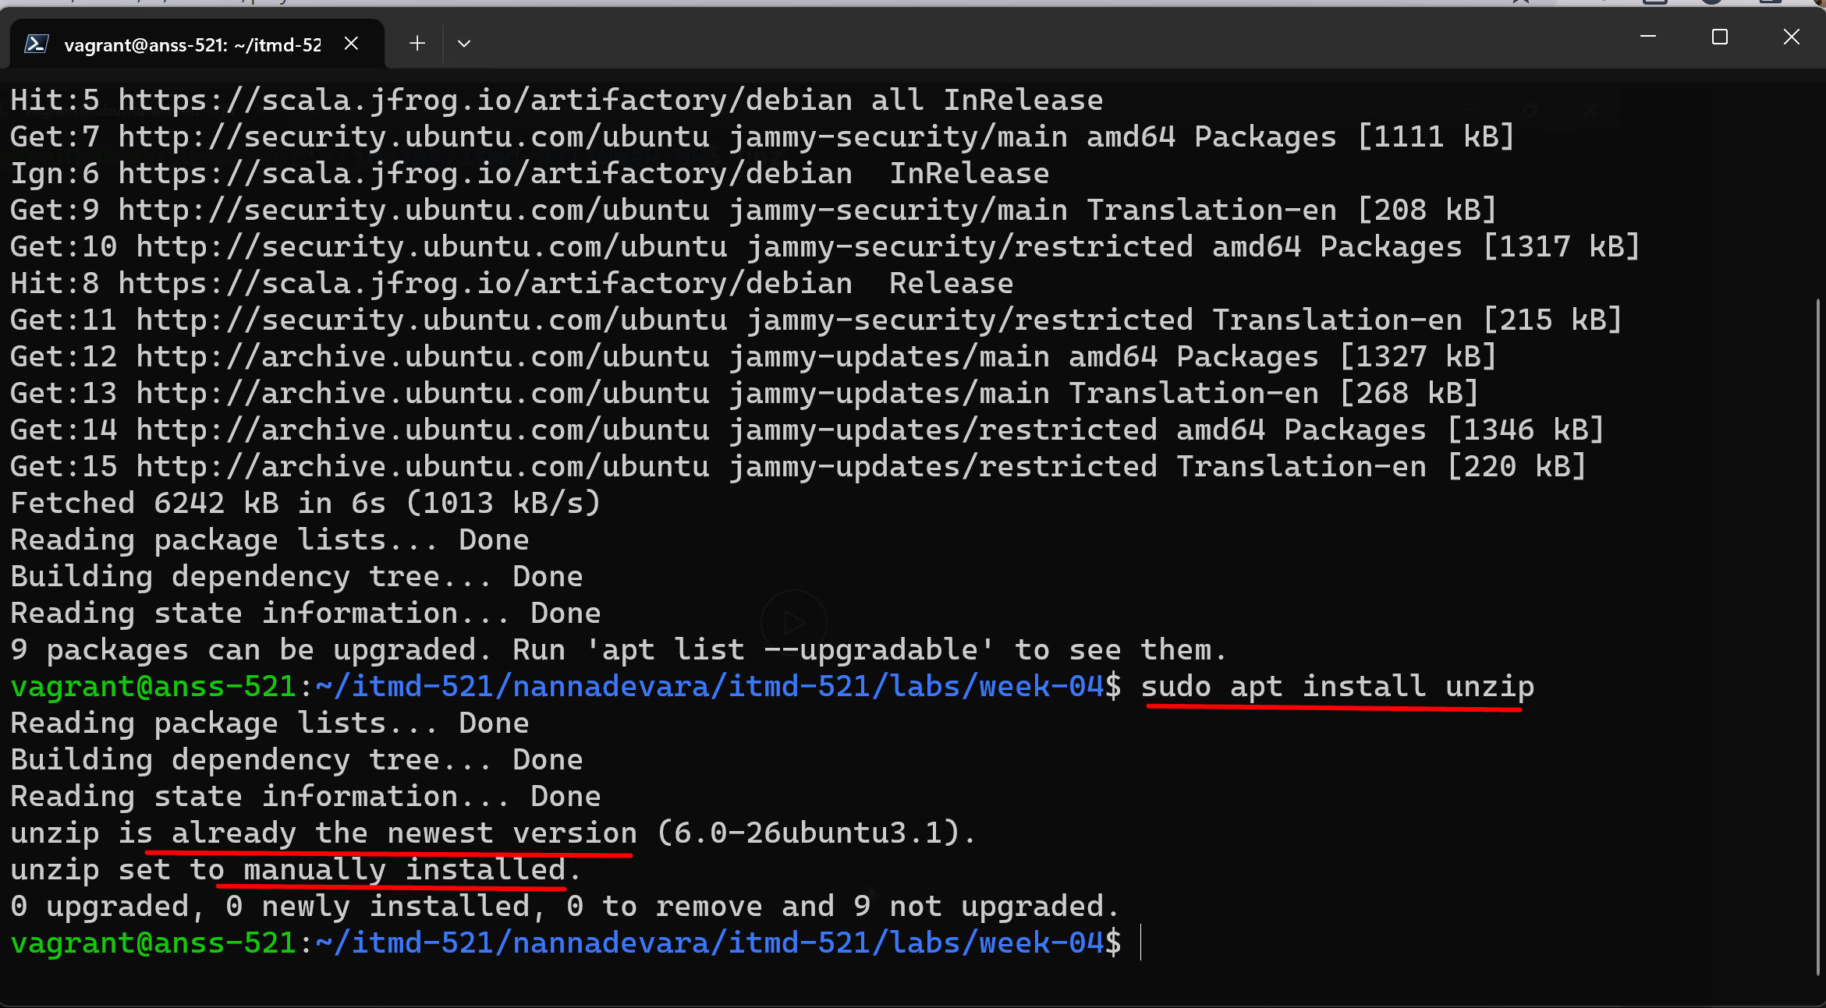

Now lets unzip the zip file :

**unzip Divvy_Trips_2015-Q1.zip**

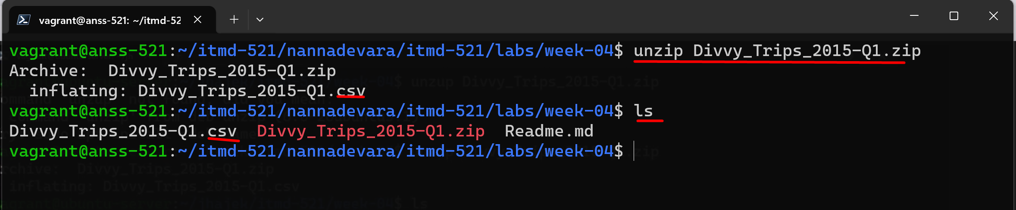

**We got our csv file…we can delete that zip file…we don’t need it…but I didn’t delete it….just in case**

**Now I added py folder and then ass-01.py file and**

**Adding pyspark code ..developing the code step by step.. doing the git push git pull**

**Here is the process**

**45 lines of code with comments**

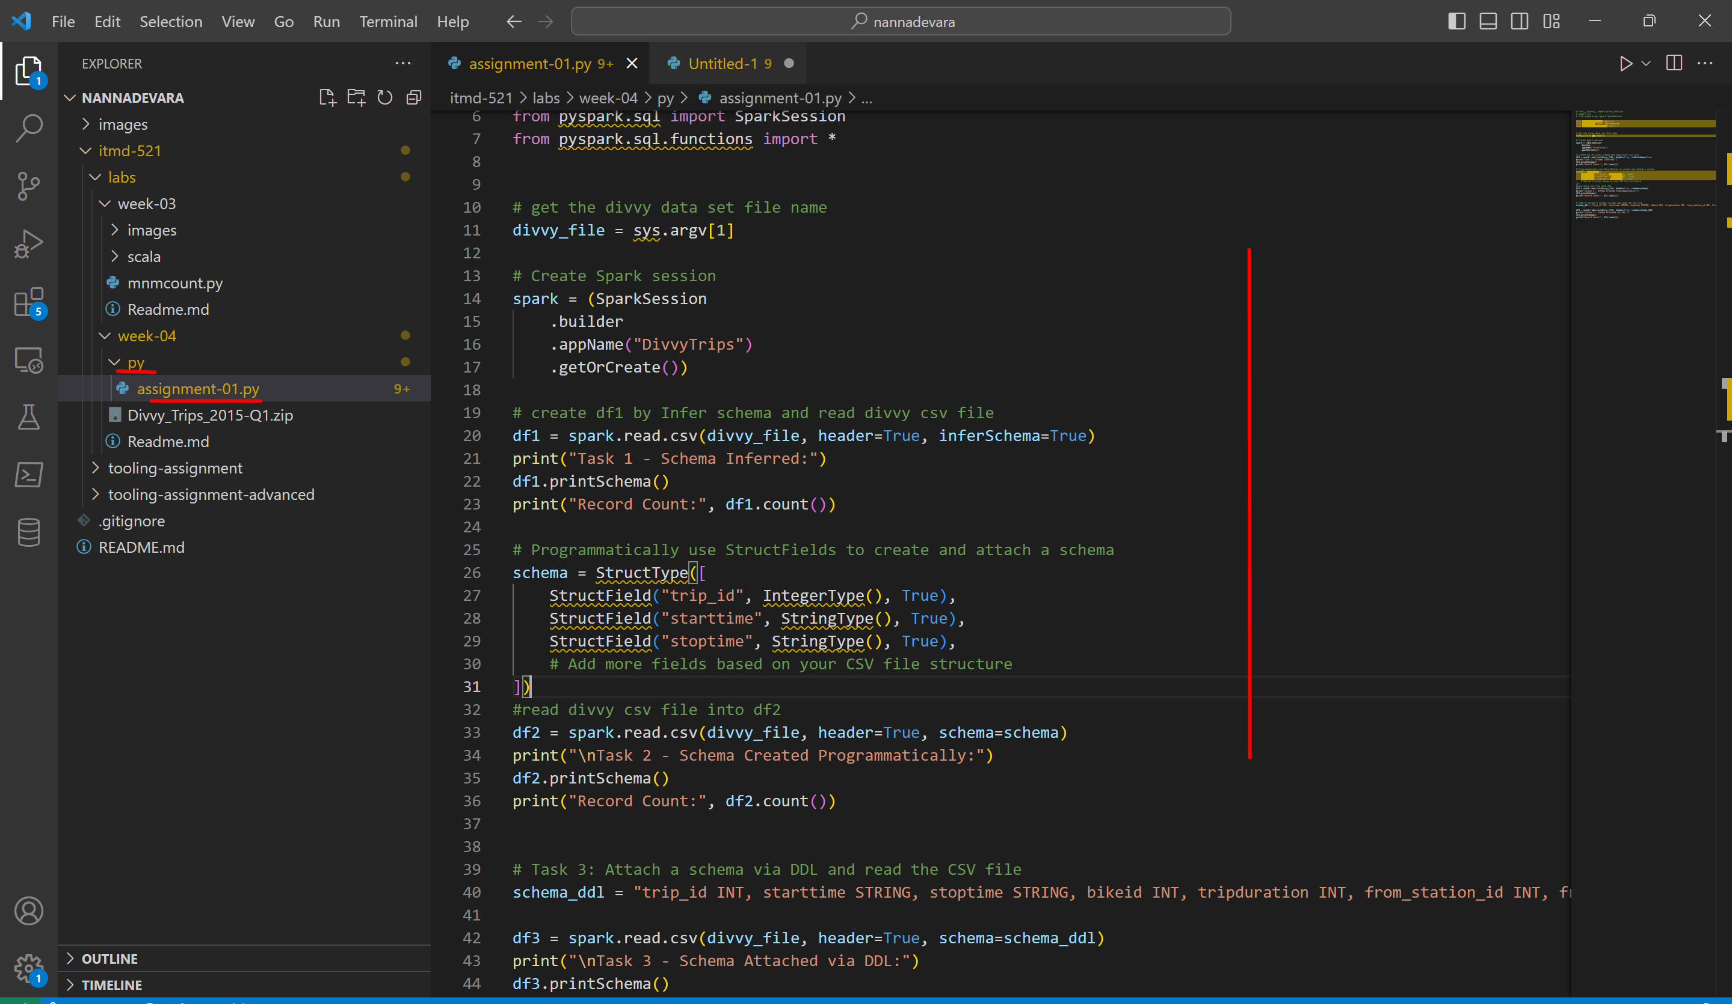

Now lets pull this code in vagrant gir repo

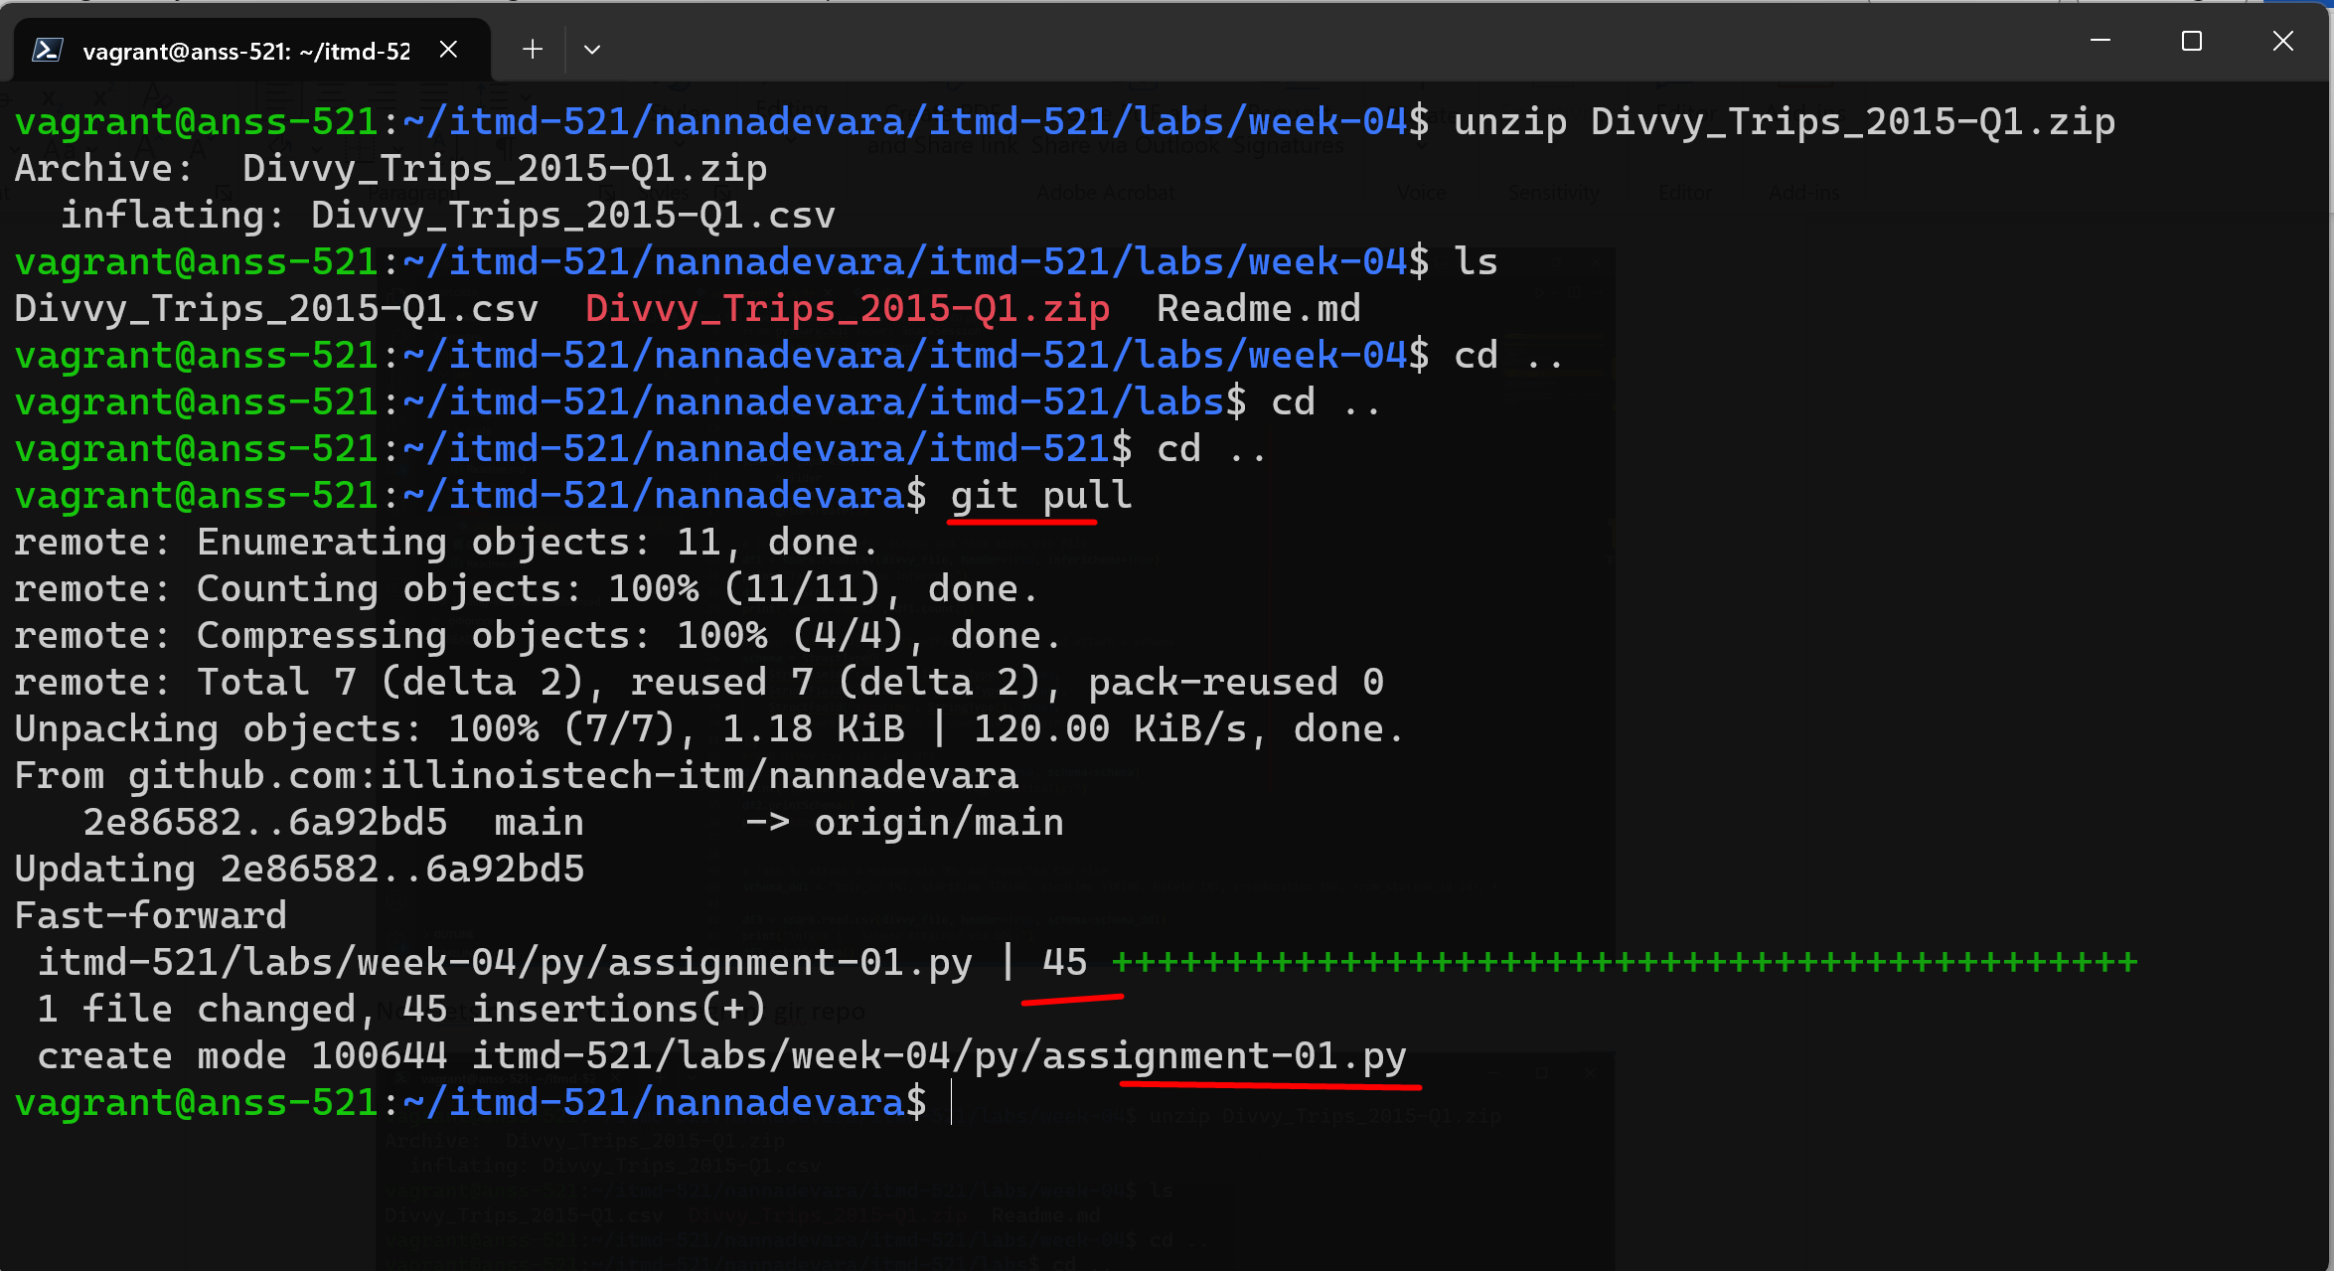

Forgot to add remaining col names in the schema..so Added some more code (col names)

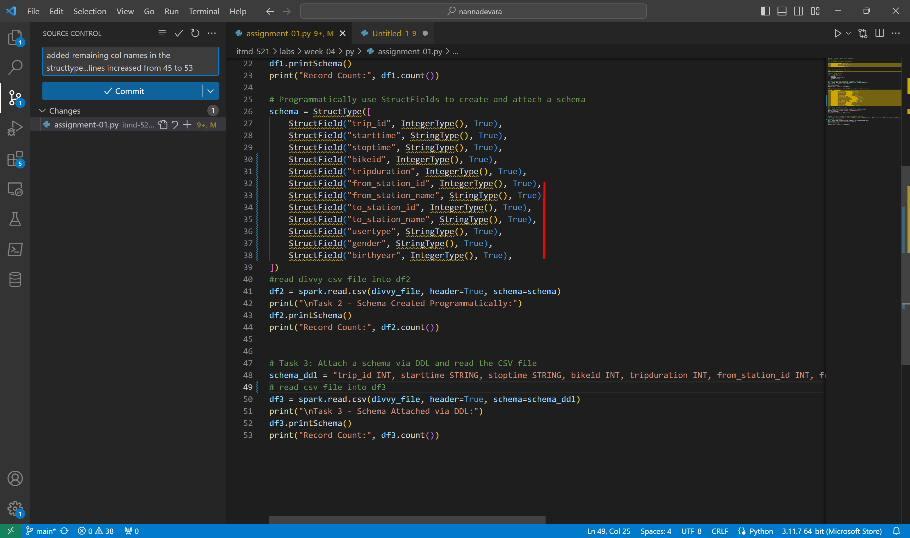

Lets again pull In vag box

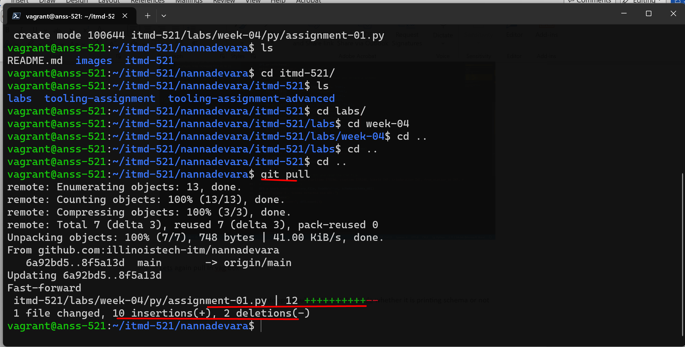

Forgot to import sys module..so added it..git push and git pull

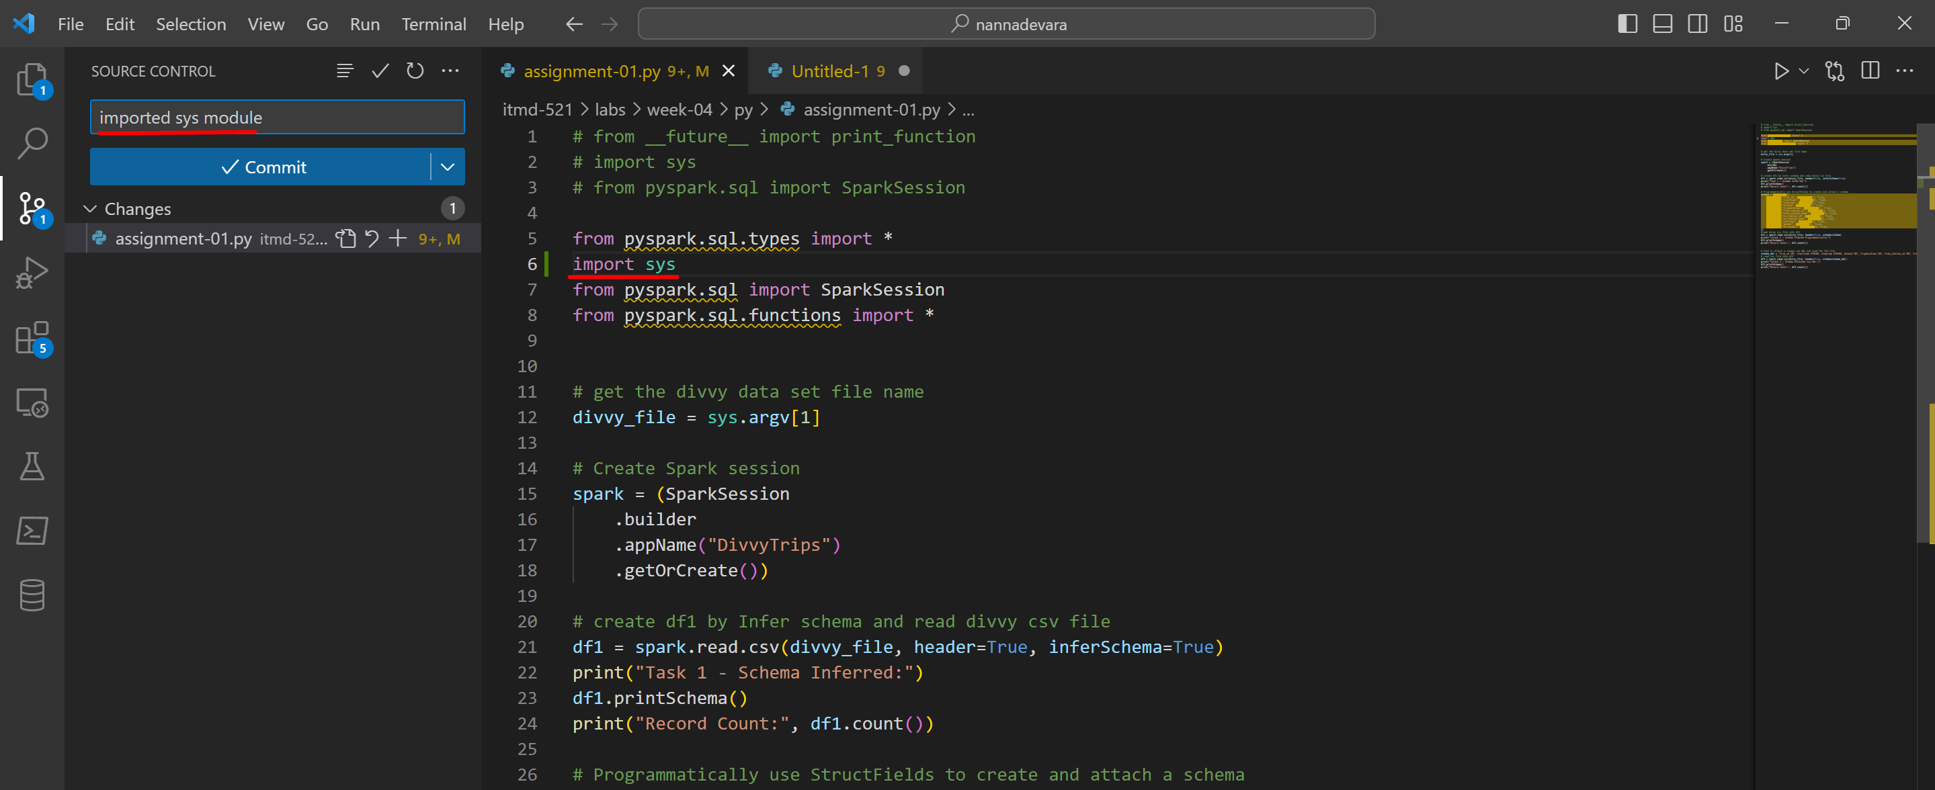 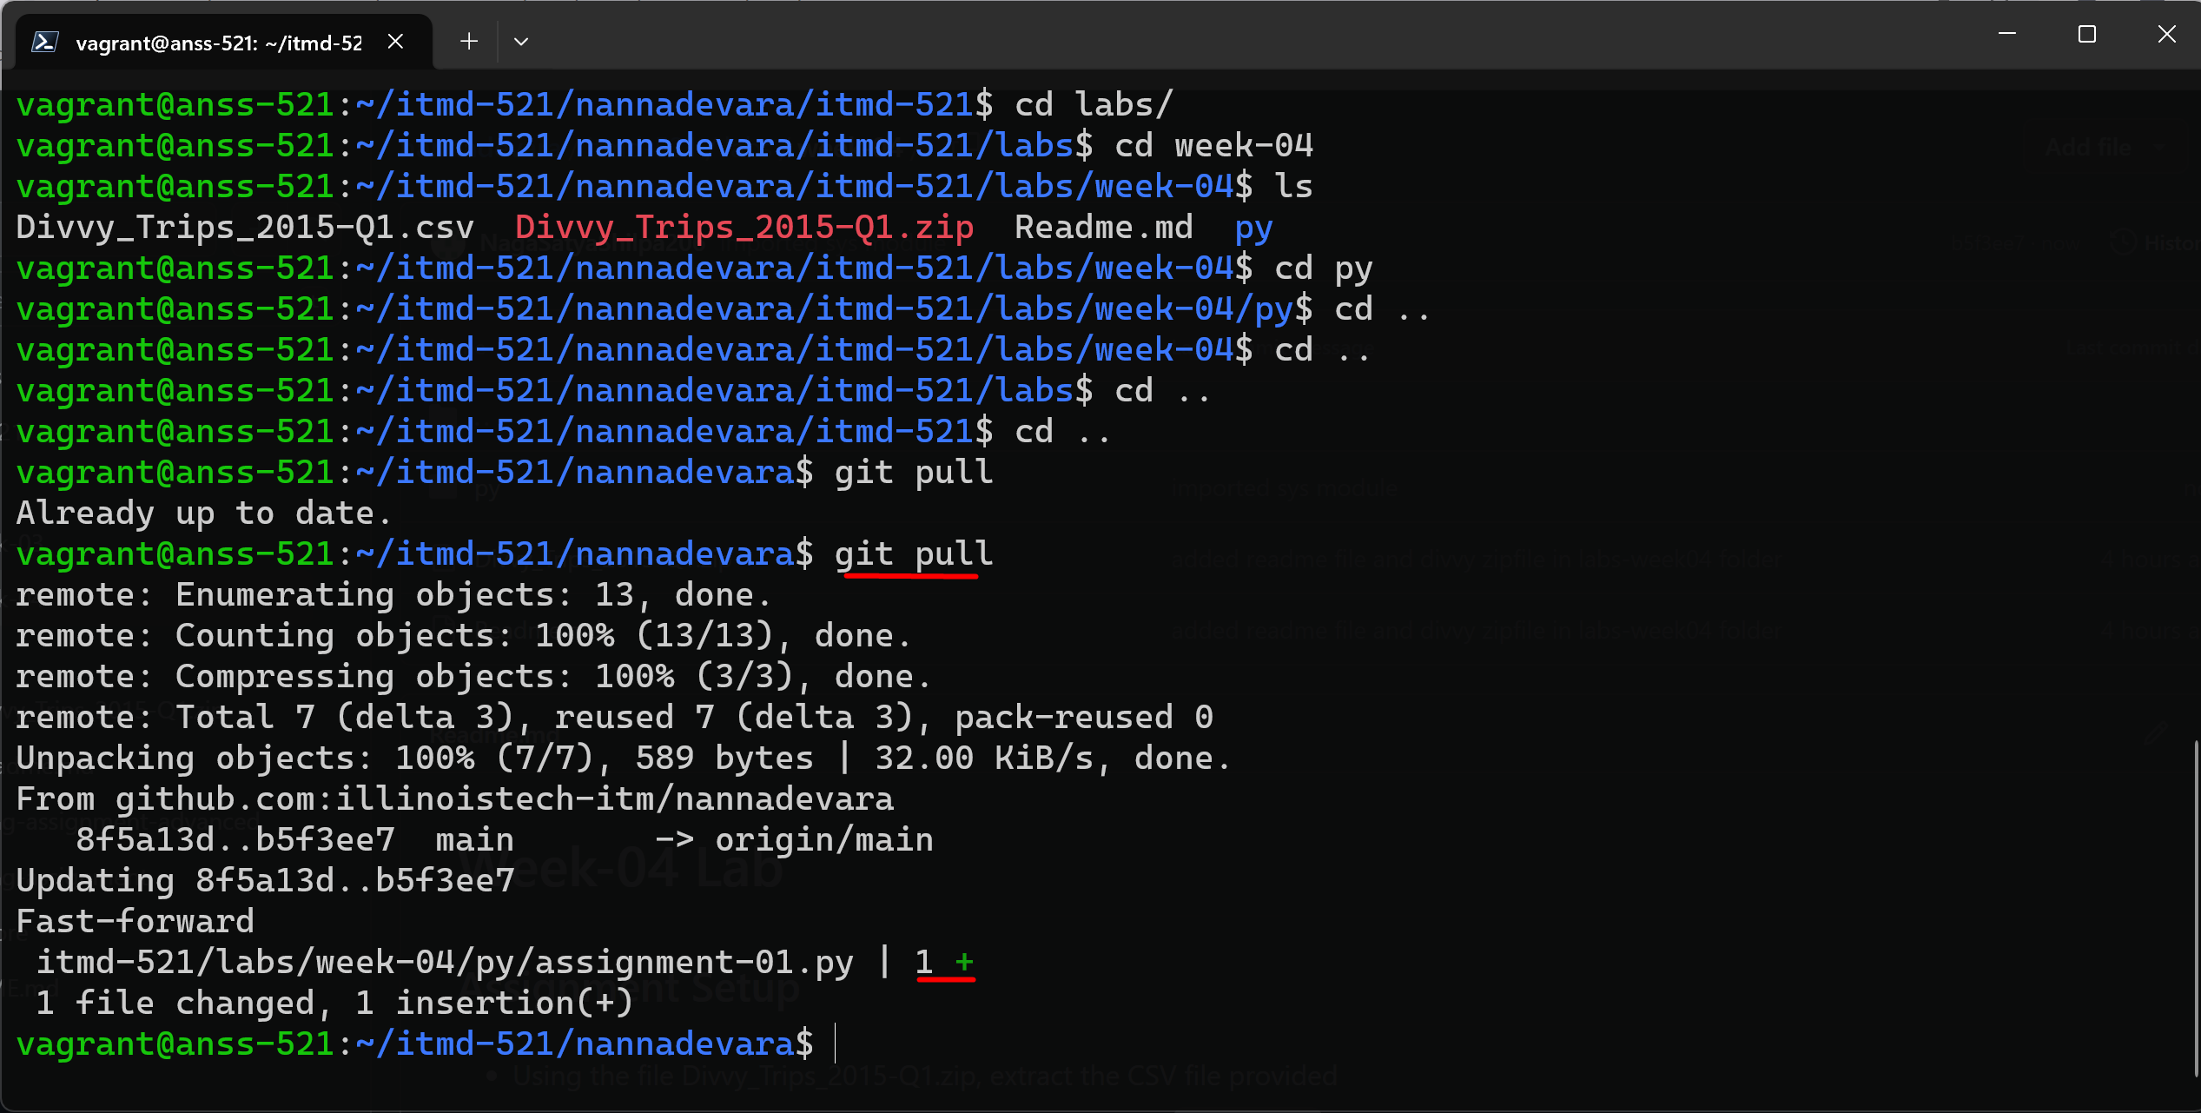

Now lets go into **py** directory and do **spark submit** to test the code whether it is printing schema or not

THIS IS PROF’s SPARK SUBMIT FOR REF TO THIS LAB:

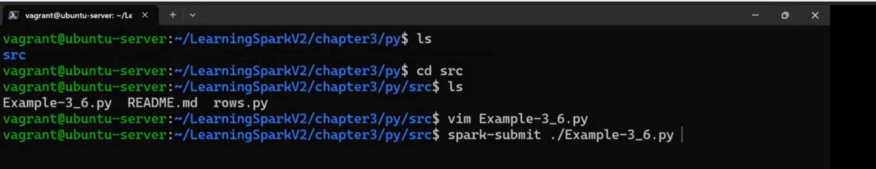

For me:

spark-submit ./assignment-01.py

ERROR:

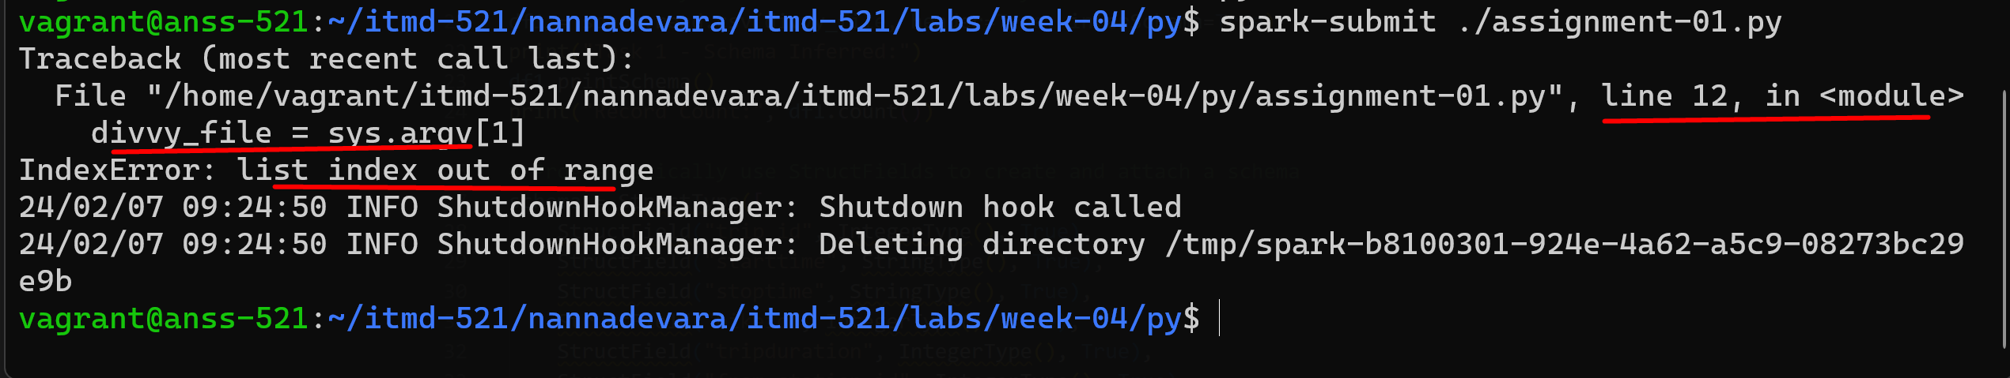

How to solve?

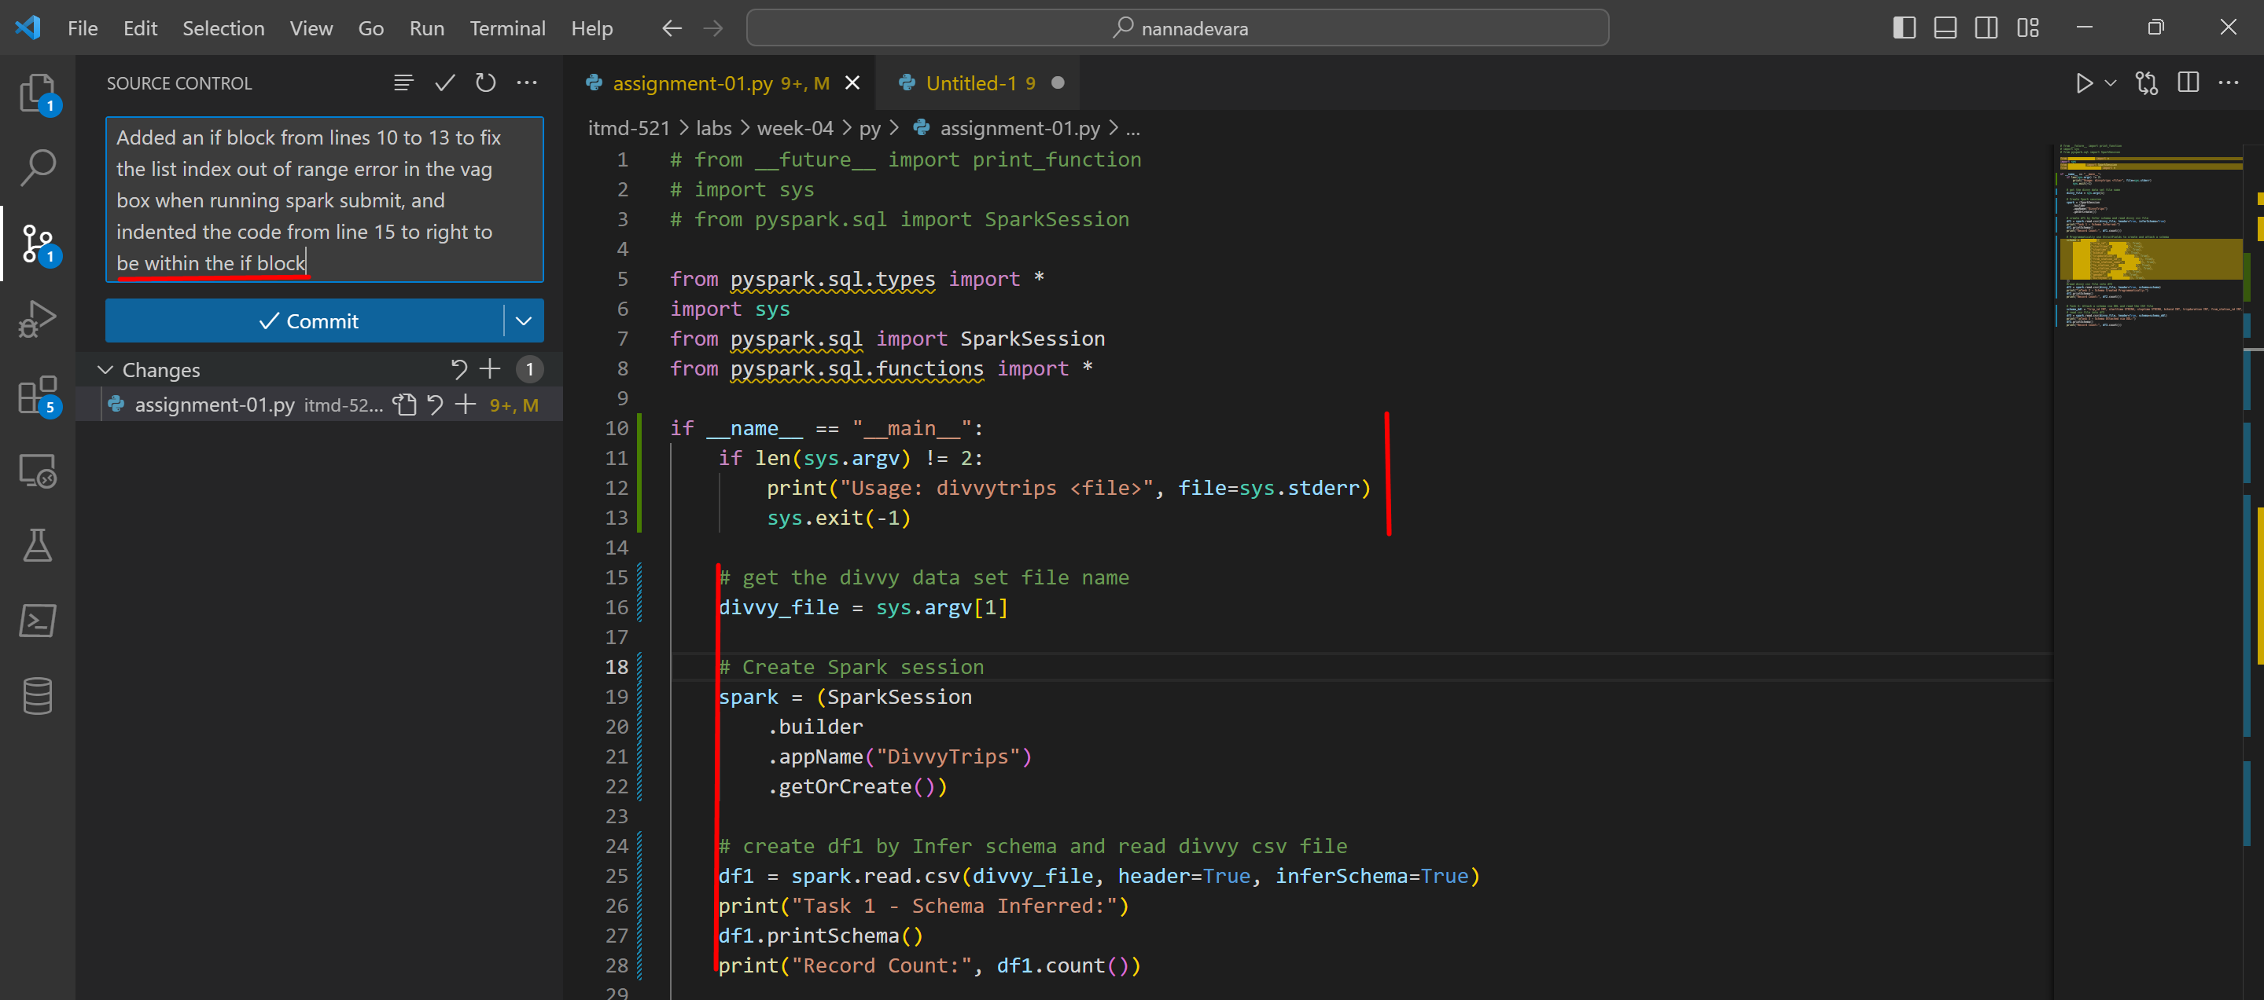

Git push and pull and do spark submit again

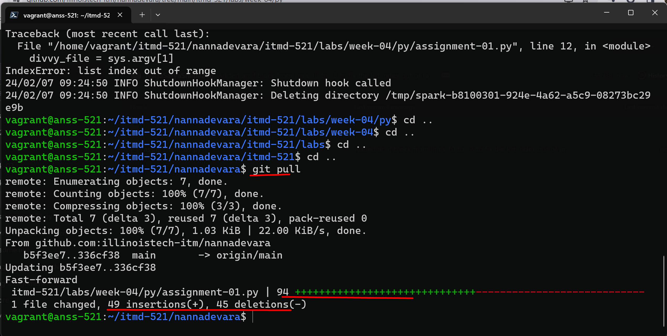

ERROR

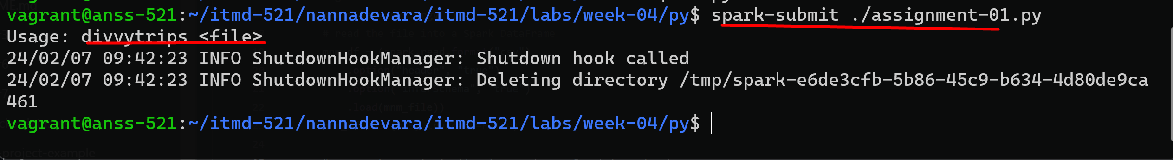

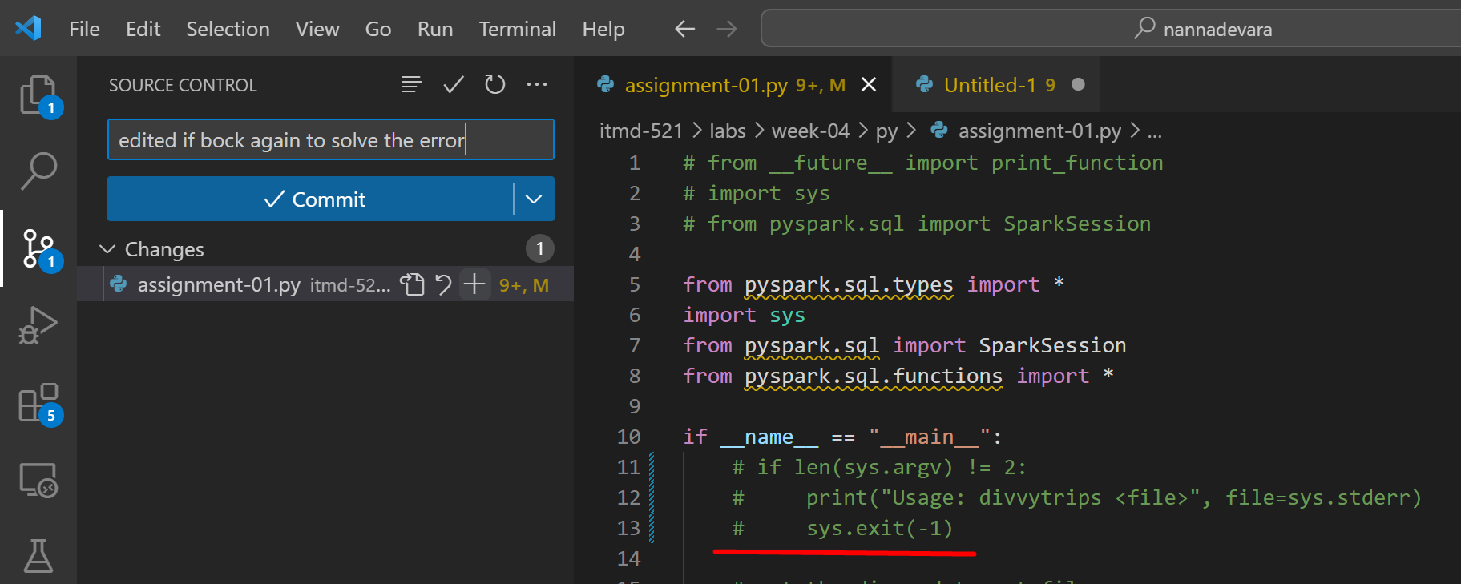

Git push and git pull

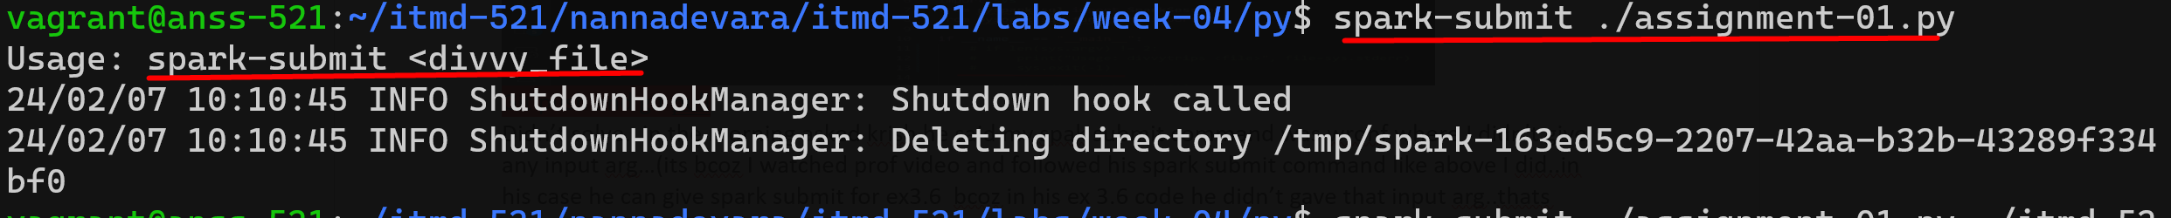

Already stayed till morning 5….nit able to solve this error…slept…

SOLVED LIKE THIS:

Woke up morning…in the morning asked krish he said my spak submit command was wronf where I didn’t give any input arg…(its bcoz I watched prof video and followed his spark submit command like above I did..in his case he can give spark submit for ex3.6 bcoz in his ex 3.6 code he didn’t gave that input arg..thats why for him no need to give input file(path) in his spark submit command)

But for us here…for the divvy pyspark code..we did the sys srg v…so we need to give the input file as an argument in our spark submit command like this.

**spark-submit ./assignment-01.py ~/itmd-521/nannadevara/itmd-521/labs/week-04/Divvy_Trips_2015-Q1.csv**

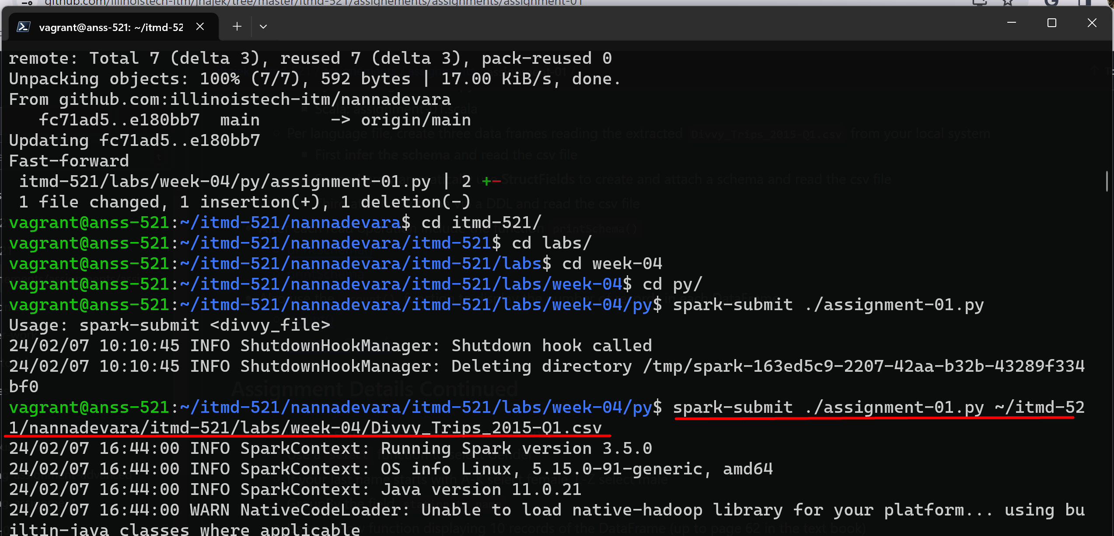

It worked…

lets move and improve our pyspark code in vs code

We are done with creating 3 df’s

Now lets do the sql logic for all the 3 df’s…done….check vs code to see the full pyspark code for this

After done with complete code run spark submit to get the required outputs:

- 3 schemas

- tranformations and actions in the end

Lets run spark submit to check whether the sql logic worked or not Go to py folder

The pyspark spark submit command is:

**spark-submit ./assignment-01.py ~/itmd-521/nannadevara/itmd-521/labs/week-04/Divvy_Trips_2015-Q1.csv**

**-worked. Got the output**

**1.printSchema inferred in Python**

**2. printSchema programmatically in Python using structfileds**

**3. printSchema via DDL in Python**

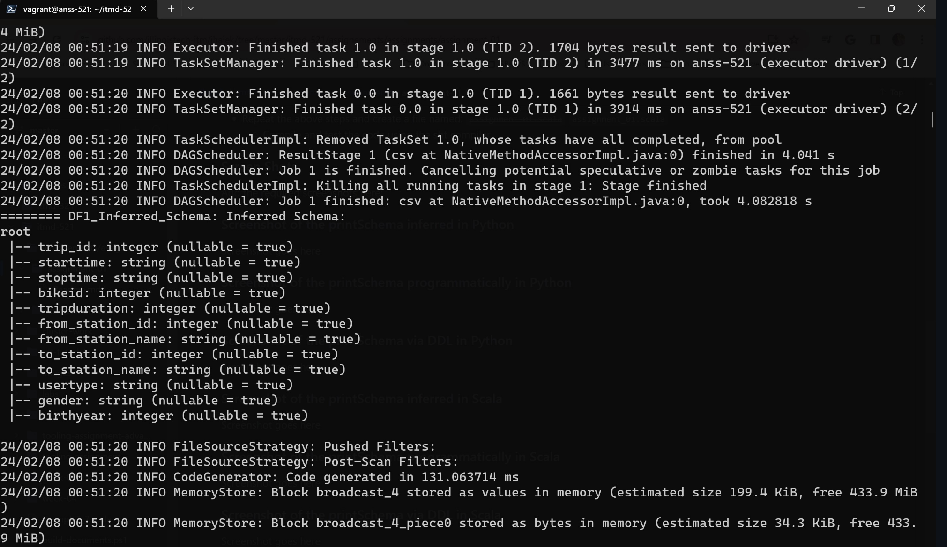

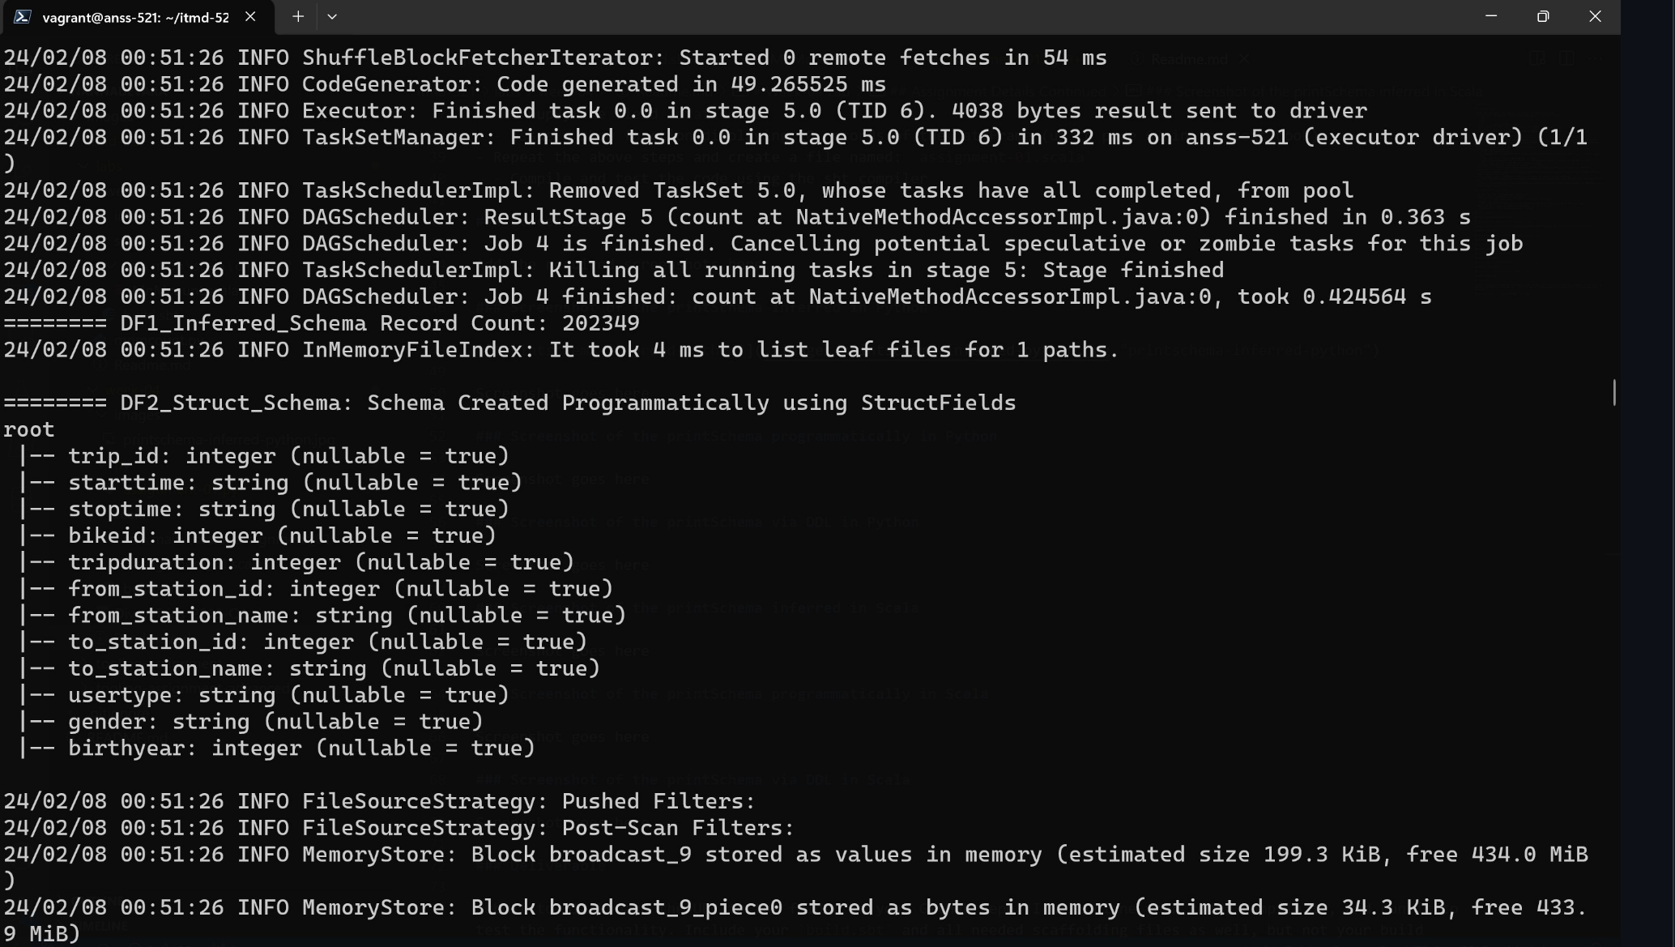

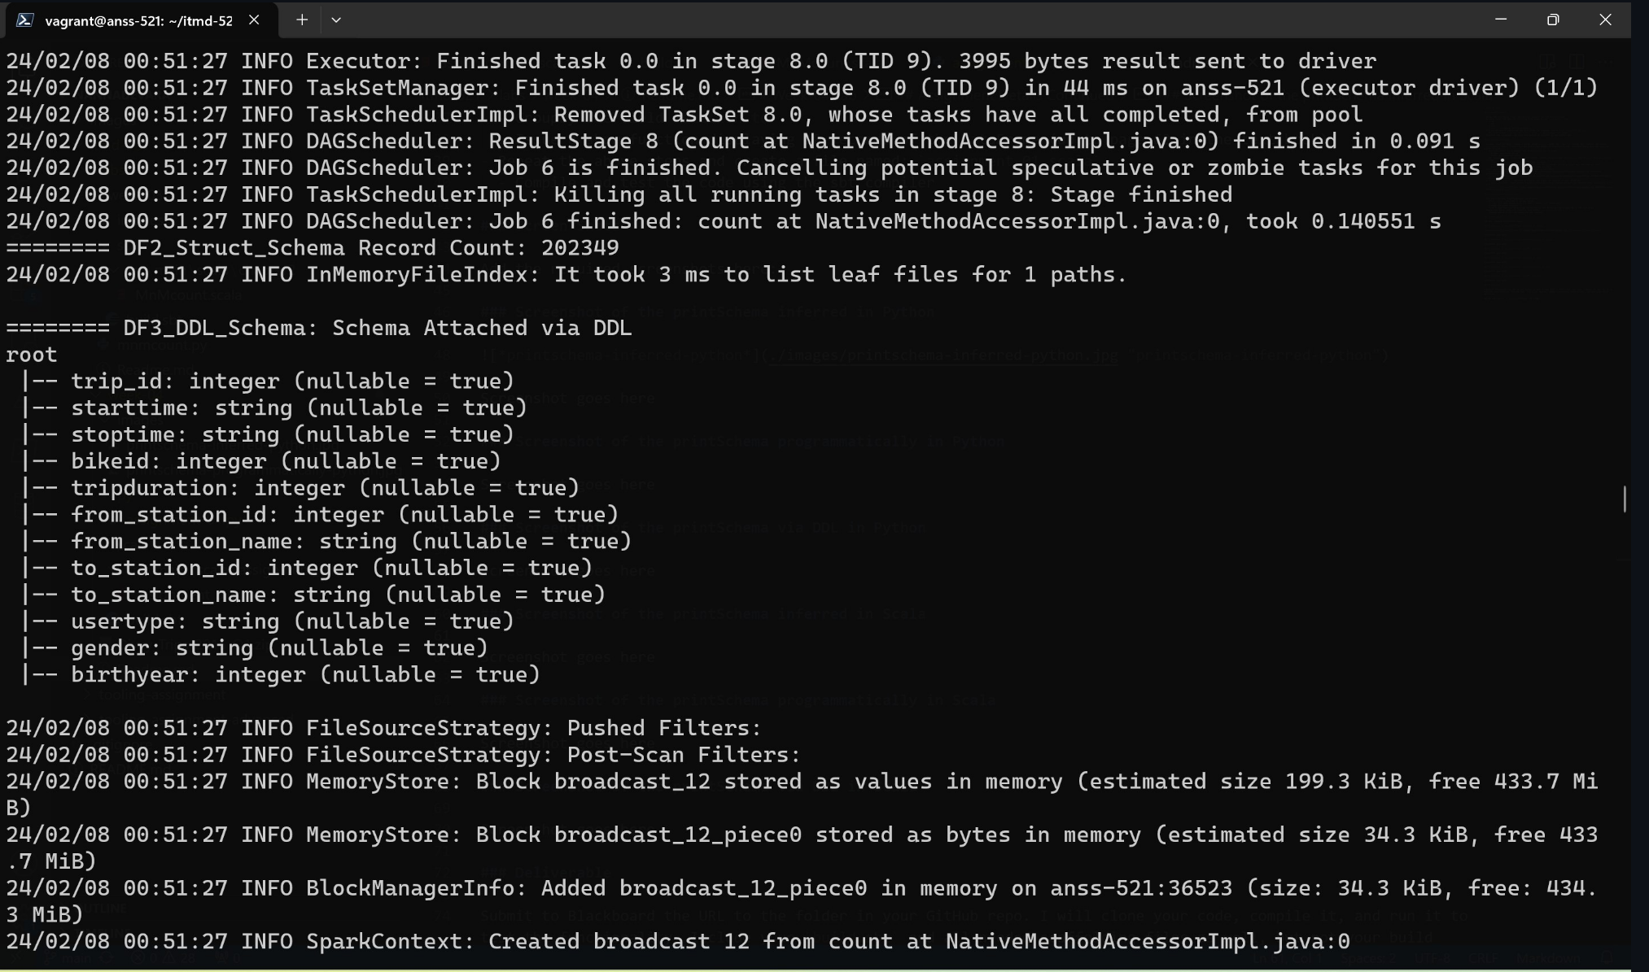

**Now**

**For scala version**

Created scala hierarchy and filled scala code and added build.sbt file in scala folder

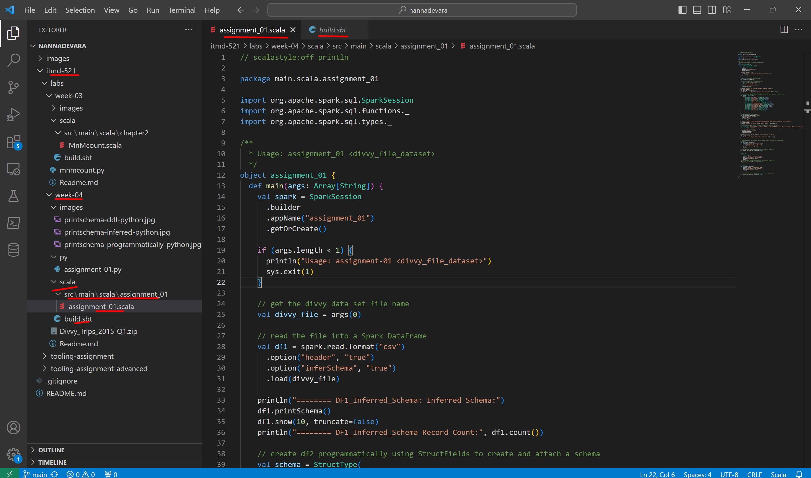

Now lets **compile** the code with **sbt clean package** in initial scala directory

It creates and gives us jar file in target directory

Prof said jar file location will be : /target/scala-2.12/main-scala-assignment_01_2.12-1.0.jar

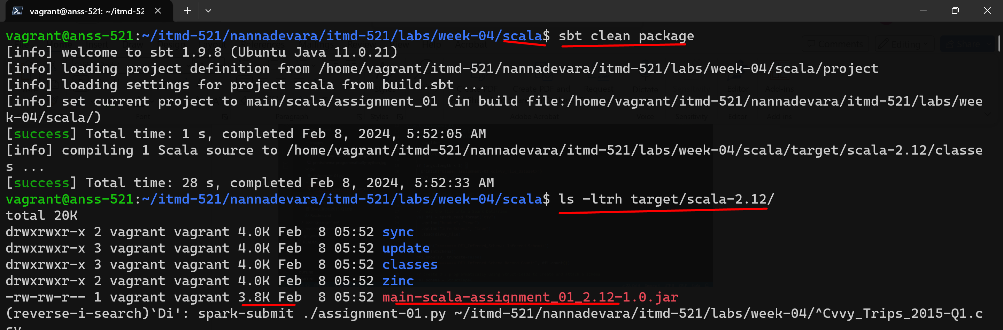

Now lets run Scala code:

Scala Spark submit command in the initial scala directory:

**spark-submit --class main.scala.assignment_01.assignment_01 ~/itmd-521/nannadevara/itmd-521/labs/week-04/scala/target/scala-2.12/main-scala-assignment_01_2.12-1.0.jar ~/itmd-521/nannadevara/itmd-521/labs/week-04/Divvy_Trips_2015-Q1.csv**

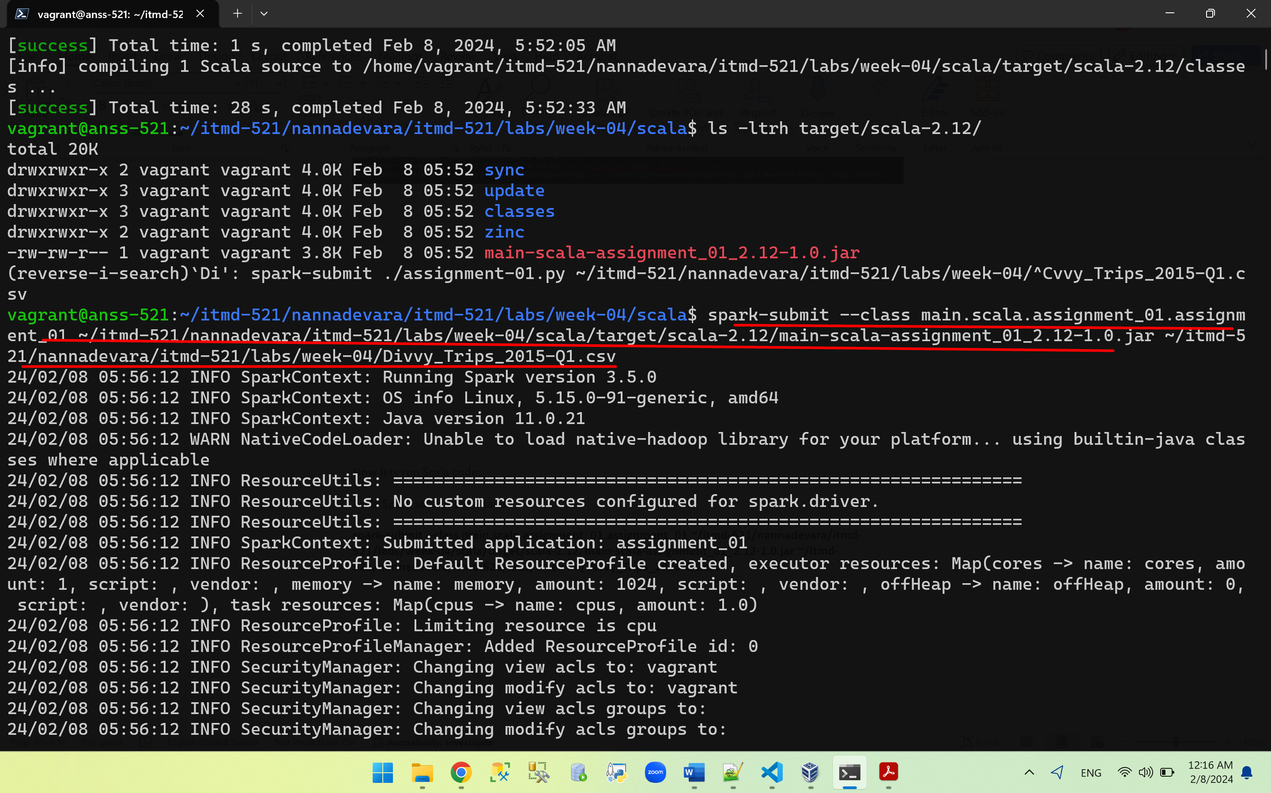

Worked! Got the outputs

3 print schemas outputs:

1. printSchema inferred in Scala

2. printSchema programmatically in Scala

3. printSchema via DDL in Scala

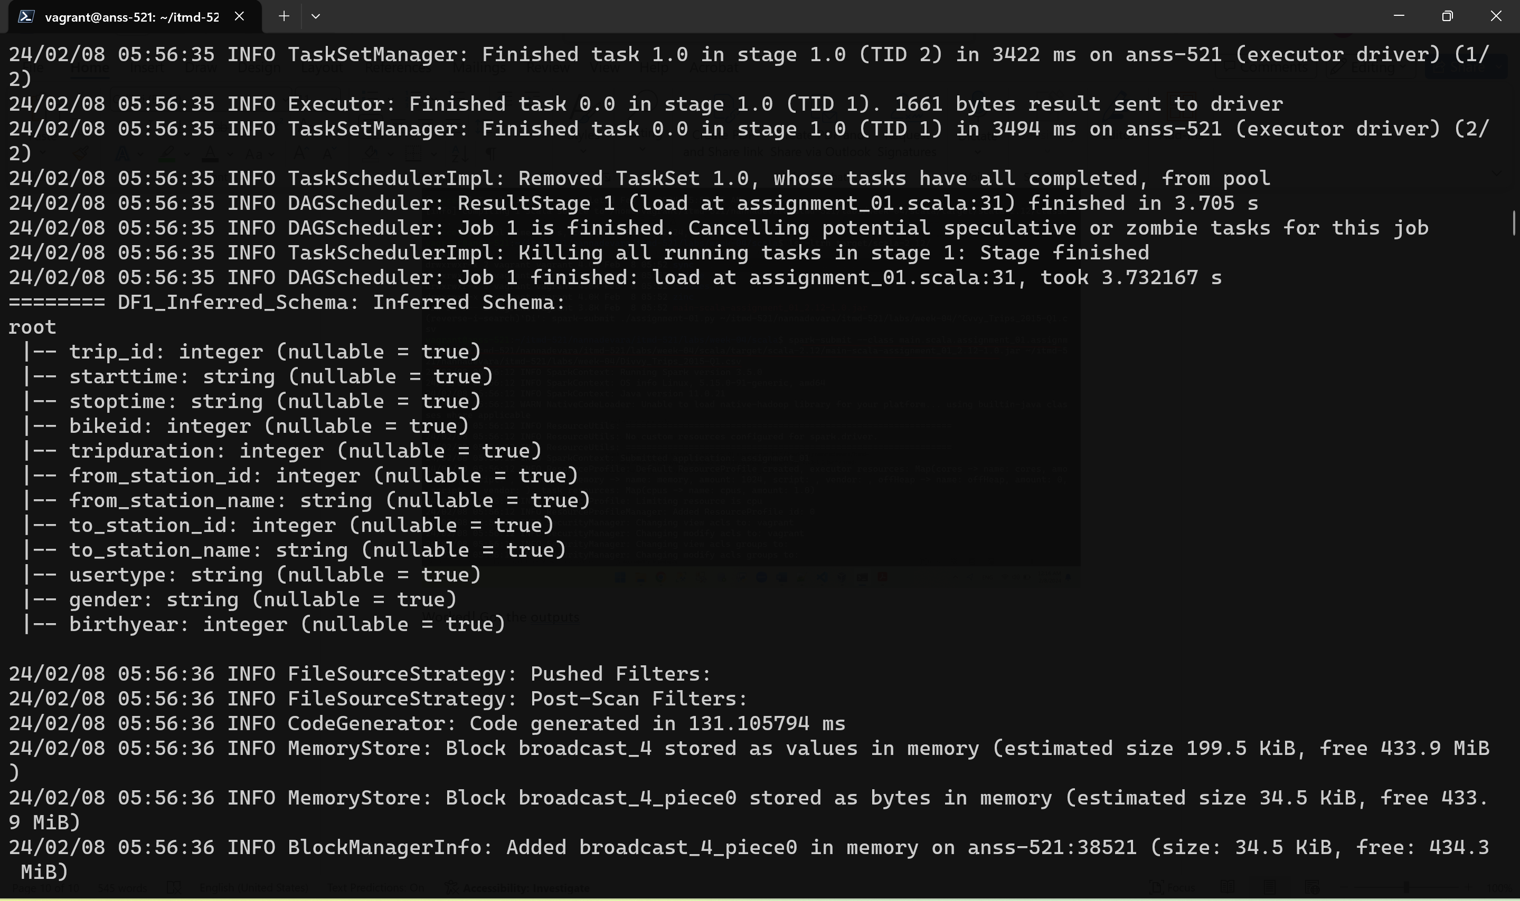

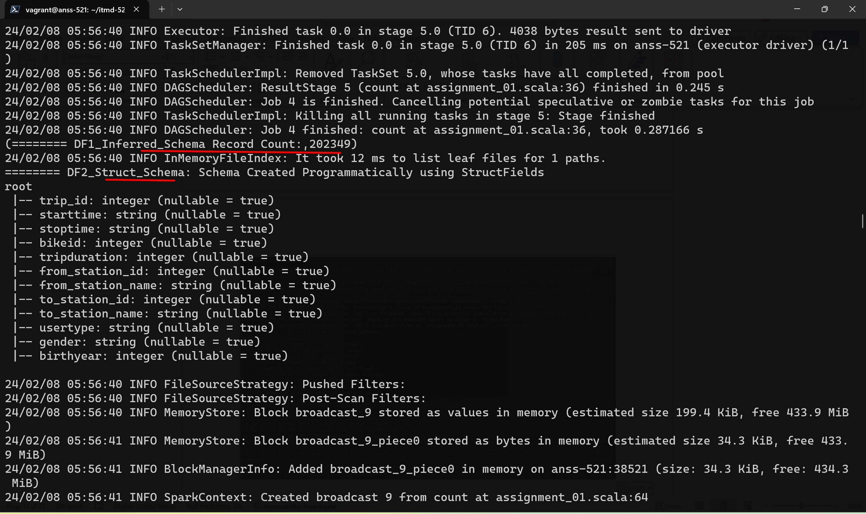

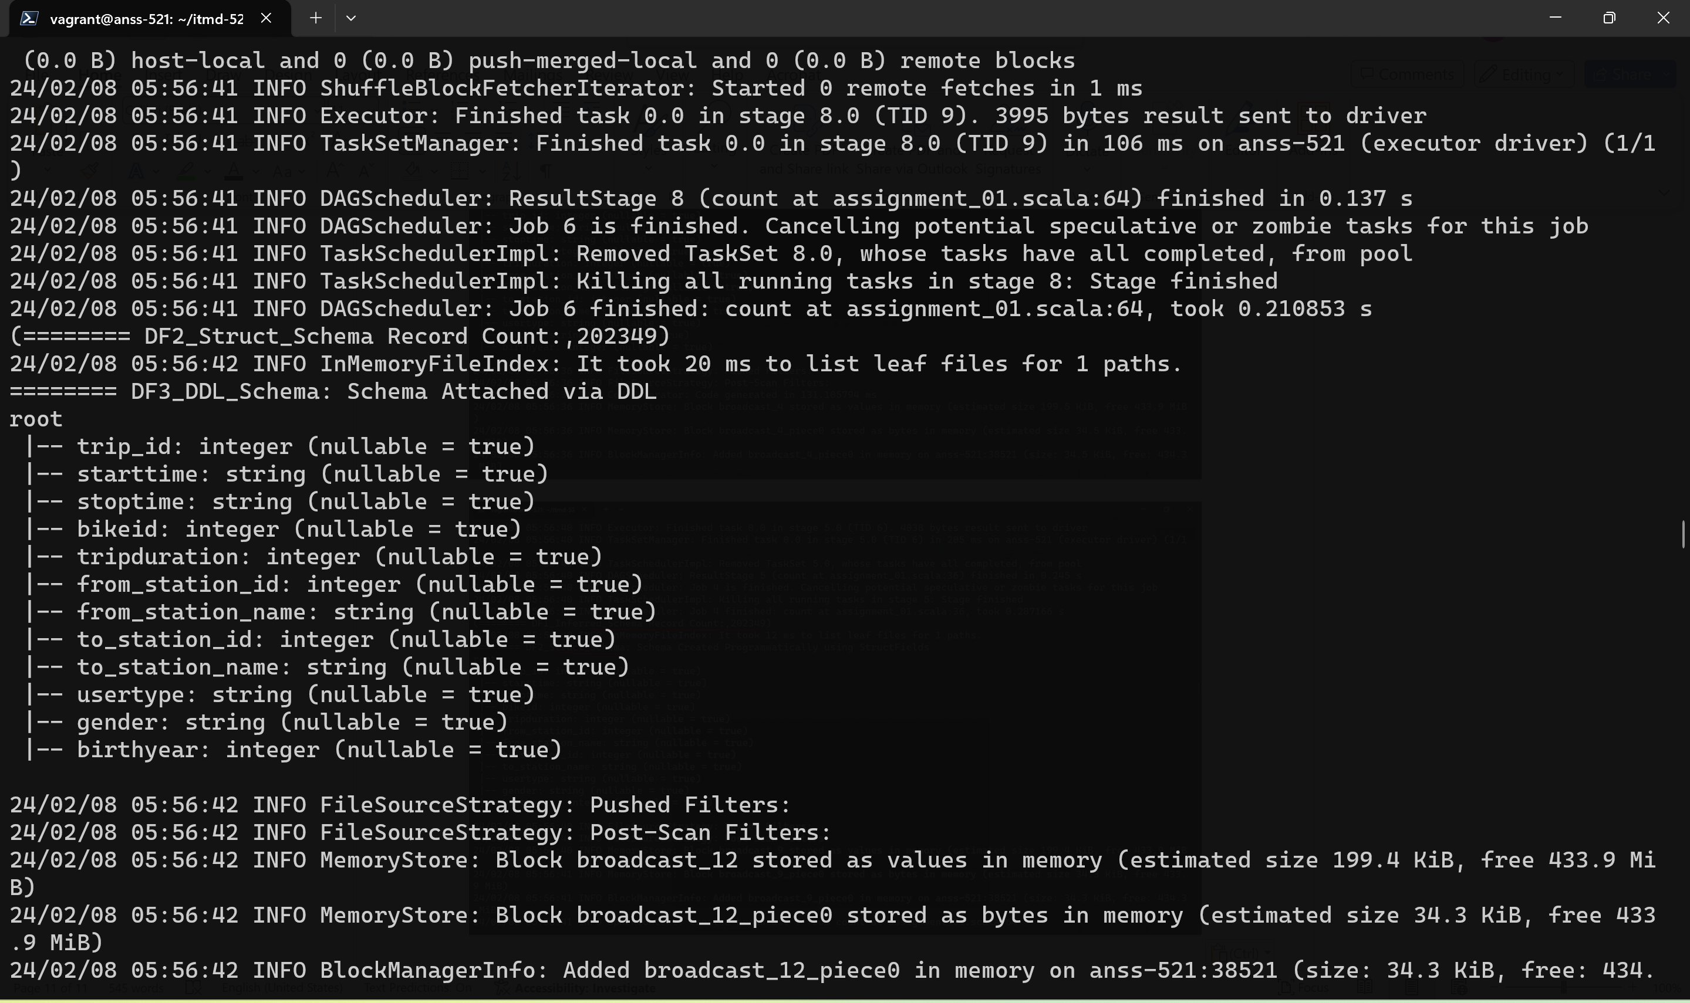

No need to take the screenshots of tranformations and actions

Prof said he will check this output while he clone and ran our code.

For ex: like this………………………………..this sc is not needed to include in readme..bcox prof said he will check this while he running our code. So he didn’t mention to include this sc in the readme deliverable

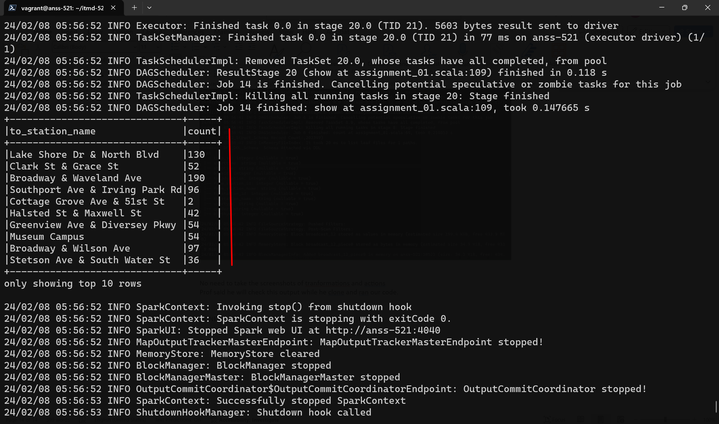

DONE.